

**Wildlife Project**

By:

Devomech Solutions Pvt. Ltd.

Date: 14-04-2023

# Current Progress:

* Decoded telemetry and recording payloads and verified the results with the device mobile app.
* Saved the data in strings and each string will be sent with the respective TOPIC to MQTT broker.

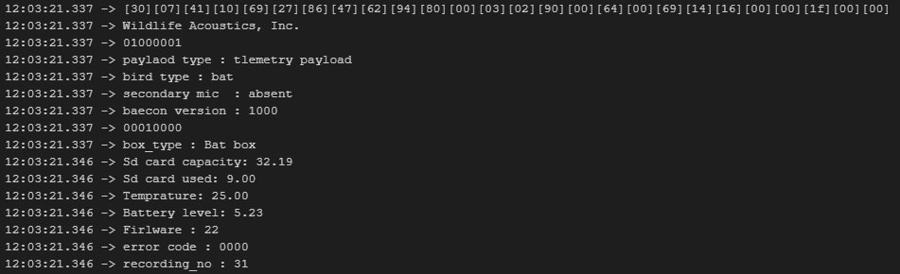

Figure 1 Telemetry payload decoding results

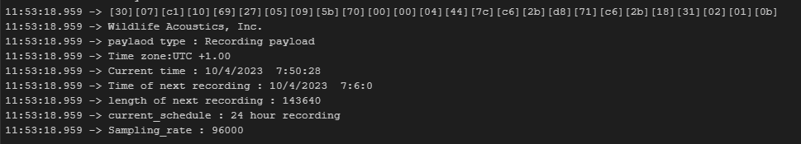

Figure 2 recording payload decoding results

* Created a MQTT broker on hivemq.cloud

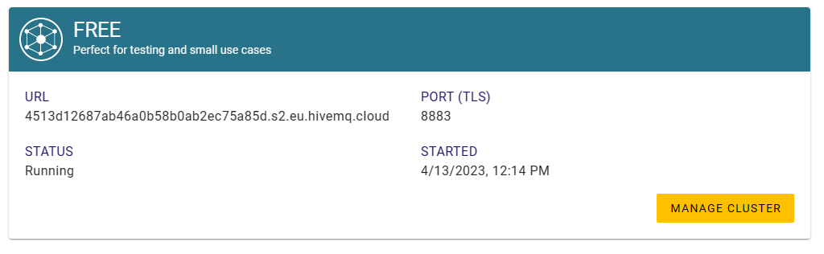

* Colour code for information

Green: Decoded

Red: Not required

Blue: already available in other payload

## Payload 1: Telemetry

1. [Byte 0&1] Manufacturer
2. [Byte 2] Beacon ID:
   * + - 1. Telemetry Beacon {0}
         2. Bird or bat {0/1}
         3. Second microphone {1}
         4. Beacon version {v,w,x,y,z}
3. [Byte 3(I)] box type b{0001}bt{0000}
4. [Byte 3(II),4,5] Serial number 5 digit hex value
5. [Byte 6,7,8,9,10(I)] Prefix first 6 char
6. [Byte 10(II), 11] Reserved field {000}
7. [Byte 12 ,13] SD card capacity low Byte FIA
8. [Byte 14,15] SD card usage low Byte FIA
9. [Byte 16,17] Temperature ¼ degree unit, FIA
10. [Byte 1 8,19] battery Voltage Millivolts
11. [Byte 20] Firmware Index
12. [Byte 21 22] Error Code

No error 0x0000

No date/time yet received from the App. 0x0001

STM32 RTC battery too low or missing. 0x0002

SD Card missing 0x0003

SD Card full 0x0004

Last SD Card Failed. 0x0005

Received STM32 firmware is corrupt. 0x0006

Received BT module firmware is corrupt. 0x0007

Update of STM32 firmware failed. 0x0008

Update of BT module firmware failed. 0x0009

Something in the configuration doesn't make sense. 0x000A

Something in the schedule doesn't make sense. 0x000B

There's no microphone. 0x000C

1. [Byte 23 24 25] Number of recordings

## Payload 2: recording

1. [Byte 0&1] Manufacturer
2. [Byte 2] Beacon ID:
   * + - 1. Recording payload
         2. Bird or bat
         3. Second microphone
         4. Beacon version
3. [Byte 3(I)] box type
4. [Byte 3(II),4,5] Serial number
5. [Byte 6,7,8,9,10(I)] Prefix
6. [Byte 10(II), 11] Reserved field
7. [Byte 12] Time Zone
8. [Byte 13 14 15 16] Standard time in seconds
9. [Byte 17 18 19 29] Next recording time
10. [Byte 21 22 23] length of next recording
11. [Byte 24] ID number of the current schedule

Custom Schedule 0x00

Bat 24 hour recording 0x01

Bat Sunrise to sunset recording. 0x02

Bat 30min before sunset to 30 min after sunrise 0x03

Bird 24 hour recording 0x04

Bird 20min each hour 0x05

Bird 5min each hour 0x06

Bird Sunrise to sunset 0x07

Bird 2hr before sunrise to 2hrs after sunset 0x08

1. [byte 25] Sample Rate

8000 0x01

12000 0x02

16000 0x03

22050 0x04

24000 0x05

32000 0x06

44100 0x07

48000 0x08

64000 0x09

88200 0x0A

96000 0x0B

256000 0x0C

384000 0x0D

500000 0x0E

# Task for next week

* Send the data to the MQTT broker and create a subscriber to read the published data for verification.
* Use built-in GSM module to connect to the network for publishing data.